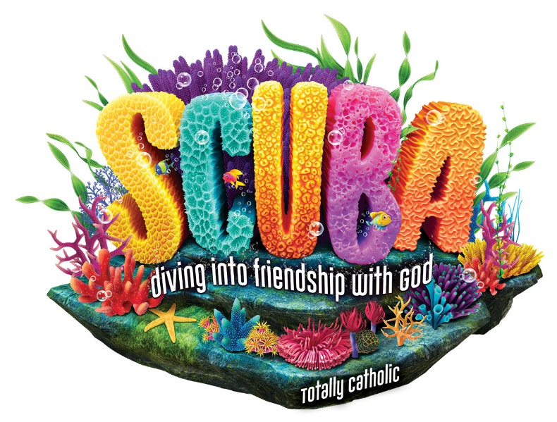
Teen/Adult Volunteer Form-Grade 7-12
August 5-9 from 9:00AM to 12:30PM

Our Lady of Pompeii Church

355 Foxon Rd East Haven, Ct 06513
Please return registration to above address
or put in the Collection Baskets
by Monday, July 15th

Contact: Sally Mucka: 203- 415-2710
Email: saintpio.rcia@gmail.com

Name: Age Grade in Fall 2023

Parent’s name: Parent’s email:

Address Town Zip

Parent’s cell: Home phone:

Allergies: Talents/Experience:

T-shirt size: Adult S Adult M Adult L Adult XL

Person to contact in case of emergency:

Telephone:

==========================================================================================================================================================================================

Photo Permission: During Vacation Bible Camp, we will be taking photos/videos of everyone as they participate in the various aspects of our faith adventure. They may be posted to our website and bulletin. We never publish names of our students.

I give permission for photos/videos of my child(ren) Yes ___ No ______

_ Parent/Guardian Signature Date

Please indicate if you can help us decorate and rehearse on Sunday, August 44h at 1:00 PM. This will be added to your service hours.

Yes, I can attend on Aug.4 ^{th} No, I am unable to attend on Aug. 4th

