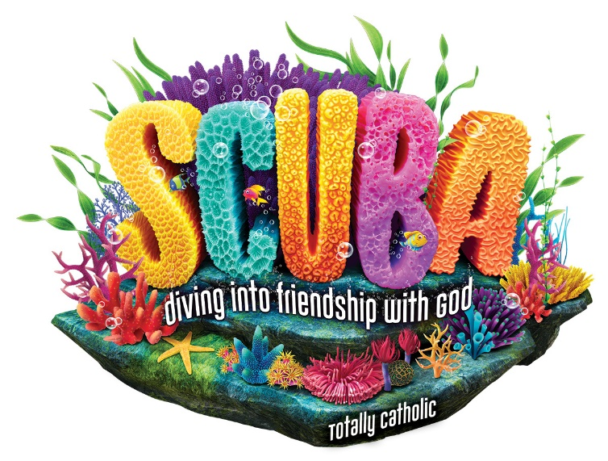
Bible Camp 2024

Date: August 5-9 from 9:00am-12:30pm Place: Our Lady of Pompeii Campus
355 Foxon Rd East Haven, Ct 06513

Who?: Students in Grades K- 6
Please return registration to the Office, Collection Baskets, or mail to the above address
By Monday July 15th

Contact: Sally Mucka 203-415-2710 or email: saintpio.rcia@gmail.com
Fee: $30.00 per child Register Soon Space is limited
Parent/ Guardian Name:

Address:

Cell Phone: Home:

Email:

Emergency Contact:

Phone: Relationship:
T-Shirt Size

Child 1 Name: Age: Grade:
YS YM YL or Adult Small

Allergies/Special Needs:

Child 2 Name: Age: Grade: YS YM YL or Adult Small

Allergies/Special Needs:

Child 3 Name: Age: Grade: YS YM YL or Adult Small

Allergies/Special Needs:
Photo Permission-
During VBS, we will be taking candid and group photos/videos of everyone as they participate in our faith adventure. The photos may be posted to our Website and Bulletin. We never Publish names of our students.
I give permission for group/individual photos/videos of my child. Yes No

Parent/Guardian Signature Date

